* 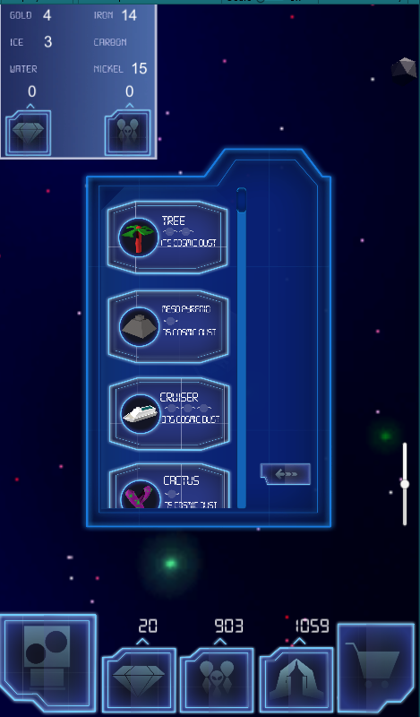First time foreverthing... so we’ll help
* Game would pause for a brief moment
* Text Boxes explaining what is about to happen & what you can do about it
* Or arrows and hands demonstrating possible interactions
* After the first time it won’t continue to annoy the player

